Main Street Guitars: Persona & Scenario

Ryan Dockstader

# Questionnaire

I had two separate questionnaires for mine, because there are two real stakeholders. The first is a group of people, local guitar players that would like to be able to browse a website for their local guitar store. For this group I gathered data about how they would like to interact with the site, what things are most important to them, and what makes them likely to purchase a guitar just from a website.

For the second questionnaire, I focused on the owner of the business as he is the one that would have to like it enough to purchase it. For him, I focused more on what he’d like his users to be able to accomplish on the site and how he would like to advertise.

## End-User Questionnaire

1. What is your priority when browsing a guitar store online?
   1. Short Answer
2. What is most likely to get you interested in purchasing a guitar?
   1. Price
   2. Brand
   3. Sale Price
   4. Features
   5. Pictures
   6. Ton Demo Video
3. What Filters are most important to you when search guitars?
   1. Category
   2. Brand
   3. Condition
   4. Price Range
   5. Custom Price Limits
   6. Customer Rating
   7. Color
   8. Orientation
   9. On Sale
4. On a scale of 1-5, how important are the following Sort options
   1. Best Match
   2. Top Sellers
   3. Price – High to Low
   4. Price – Low to High
   5. Newest First
   6. Brand Name (A-Z)
5. What makes you most likely to click on a banner ad?
   1. Short Answer

## Owner Questionnaire

1. What is your priority for users to see when browsing your store online?
   1. Short Answer
2. What do you want to be the most important thing on the website (price, branding, type, picture, etc.)?
   1. Short Answer
3. What filters are important for you to have for your users?
   1. Short Answer
4. What sort options would you want for a list of guitars?
   1. Short Answer
5. What would be the #1 branding message you’d want on your site?
   1. Short Answer

# Summaries

## End Users

Based on the responses, the end users have pretty basic needs when it comes to the site. They want it as simple as possible, with expansive search functionality, the ability to write and read reviews, and expert advice on choosing the right guitar. They have strong brand recognition with names such as Fender and Gibson, and are typically drawn to brands they are familiar with. All the users said the more filters the better, but the only filter agreed as necessary by all users is a Price Range, with very few having a desire to be able to pick their own custom price range.

For sorting options, Best Match, Price – Low to High, and Brand name took the highest results. So those three should be a focus, and the rest of them can be “good to have”.

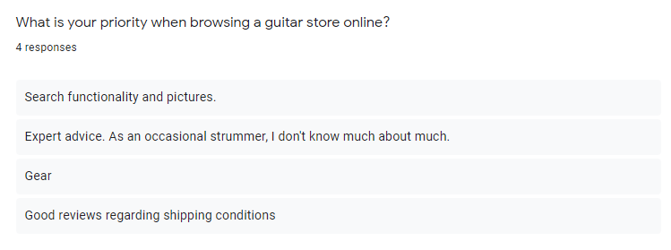

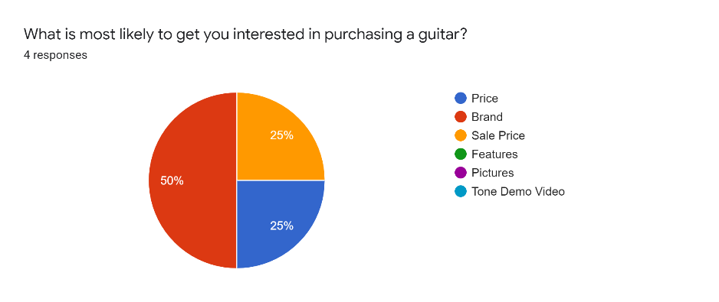

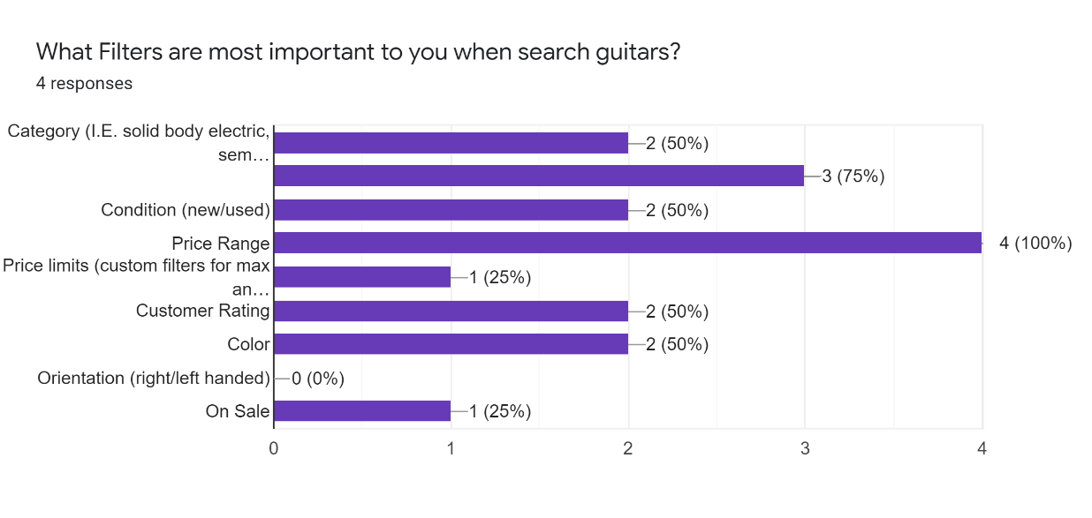

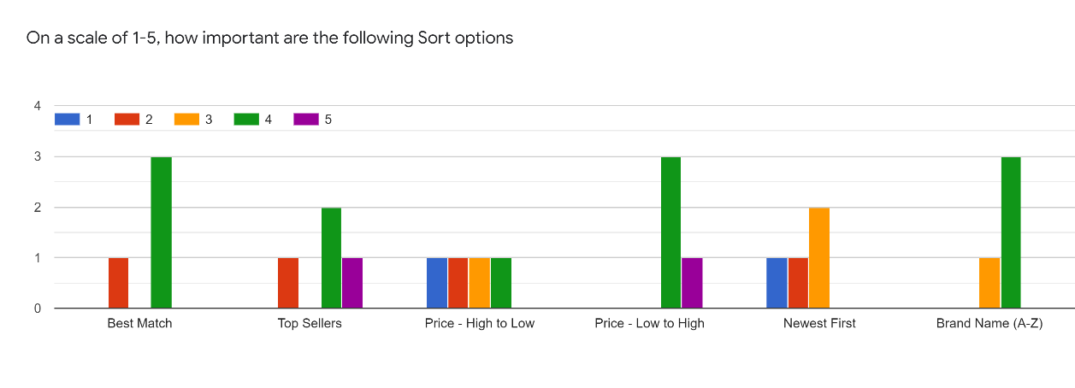

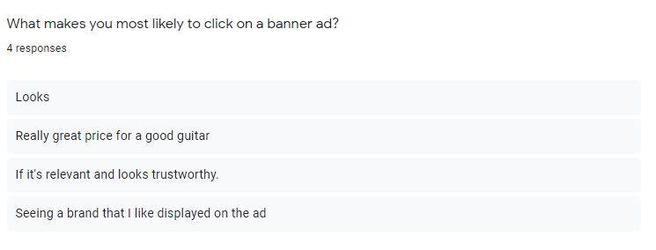

## Owner

1. What is your priority for users to see when browsing your store online?
   1. The online store should give an idea of what the shop is about. It needs to show the brands in the store, quality of the products and staff members, and the wide selection. It should also be something that will speak to the customer encouraging them to visit the site and store more frequently
2. What do you want to be the most important thing on the website?
   1. The store is very proud of what brands they have to offer, and they want the big four to be featured near the top. Fender, Gibson, Taylor, and Martin. The primary idea that was mentioned was to create a banner with the name of the shop, with the four headstocks featured.
3. What filters are important for you to have for your users?
   1. Acoustic or electric
   2. String type (Nylon or steel)
   3. Body Shape (dreadnaught, cut-away, etc)
   4. Separated by brand
   5. Secondary
      1. Color filters, best match, top seller. As many options as possible
4. What sort options would you want for a list of guitars?
   1. Standard selection. Same as Guitar Center, Sweet Water, Fender, etc.
5. #1 Branding message?
   1. The guitars really speak for themselves. The store has made a large effort to stock the store with known brands such as Fender, Gibson, Martin, Taylor, Epiphone, Squire, etc. That should be front and center for the brand recognition.

# Persona



**Name:** Dylan

**Age:** 25

**Bio:** Dylan is a single male. He recently graduated from college. He got his bachelor’s degree in software engineering and found a job at a very successful startup during his last semester of school. Currently Dylan is making a lot more money then he ever has in his life, so he has a pretty high expendable income. He is married, and his wife will shortly be starting her senior year in college. Dylan grew up loving guitars. He got a cheap electric guitar and amp in middle school and have been dabbling ever since. He really loves to look at guitars and play as many as he can. Since he’s come into some more money, he’s been really interest in buying a more expensive guitar and has been looking at Gibson and Fender guitars at least once a week.

# Scenario

Dylan is really wanting to buy a new guitar and has decided to get a solid body electric guitar. He keeps switching between a Fender American Elite Stratocaster in Aged Cherry Bust, and a Gibson Les Paul Standard ‘60s in Burbon Burst. He really wants to play them both so he can A/B them (he is a software engineer now, after all) but doesn’t want to hop from shop to shop. He really wants to find a shop that has them both so he can go play them, and probably purchase one.

# Criteria

|  |  |  |
| --- | --- | --- |
| Variable | Priority | Criteria |
| Efficiency | 1 | Dylan isn’t going to want to wait for loading times, or search very long for website controls since he is going to be looking at serval different sites |
| Learnability | 3 | There should be very little learning required to use the site, since it should follow standard practices |
| Familiarity | 2 | The site needs to feel like a site that shows guitars. It needs to have filter and sort buttons in a similar place, and display information in a very digestible way |
| Simplicity | 1 | The site must be very simple. It should show the guitars to the Dylan and show if they are in stock |
| Mapping | 2 | Mapping is important. The site needs to tell the user what button sorts, and what button filters |
| Motivation | 1 | Motivation is extremely important. The user should be motivated to visit the site regularly to check stock, prices, and reviews |
| Trust | 2 | The price listed on the site should never be higher then it is in the store. However, if the price online is higher then the one on the store and the user decides to go in and check the store they will often be happy, and more likely to purchase it on the spot. |
| Visibility | 1 | The site needs to function well, and it needs to look good while doing it. If it looks like a site from the 90’s, people aren’t going to want to use it. |

# Rubric

|  |  |  |  |  |  |
| --- | --- | --- | --- | --- | --- |
|  | **Exceptional 100%** | **Good 90%** | **Acceptable 70%** | **Developing 50%** | **Missing 0%** |
| **Efficiency 20%** | The page loads quickly, and refreshes quickly when a new filter is selected | The page loads within a few seconds, and loads quickly when a filter is selected | The page and filter both load within a few seconds | The page and filter take a while to load | The page and filter never load. |
| **Simplicity 15%** | The site is easy to use regardless of how many features it has | The site has a lot of features, but some of them are hard to use | The site has a few features, and only some are hard to use | The site only has a few features and they are all hard to use | The site has no features |
| **Motivation** | Users are motivated to check the site for guitars, and to learn about them. | Users will often choose to check the site when looking for guitars | Users check the site 50% of the time when looking for a new guitar | Users don’t check the site very often, and like other sites better | Users only check the site if they absolutely have to |
| **Visibility** | The site has a clean, modern look | The site looks a little cluttered | The site is cluttered and doesn’t implement a recent design standard | The site looks like it hasn’t been updated in 20 years | The site does not exist |
| **Trust** | The prices on the site are accurate | The prices on the site are never less then what is advertised in the store | The prices and data on the site are sometime inaccurate | The prices, stock, and data are almost always out of date | The site does not exist |
| **Mapping** | All filters and sorting options are labeled | Most filters and sorting options are labeled | Half of the filters and sorting options are labeled | Only a few of the filters and sorting options are labeled | None of the filters and sorting options are labeled |
| **Familiarity** | The site looks and feels like a guitar website | The site contains a lot of aspects of a guitar website | The site somewhat resembles a guitar website | The site doesn’t really look like a guitar website | The site doesn’t exist |